WE’RE HIRING
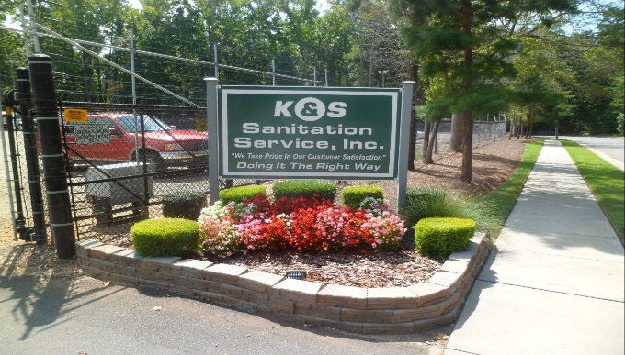
K&S SANITATION SERVICE IS NOW HIRING!
WE ARE LOOKING FOR PROFESSIONAL SANTITATION WORKERS. MUST BE ABLE TO ARRIVE AT WORK BEFORE 6AM AND STAY UNTIL JOB IS COMPLETED.
If you want to be a part of great company, we are offering great benefits:
- Drivers starting pay $24.00 (must have 2 years CDL drivers experience).
- Health Insurance
- Free Dental Insurance
- 401 K Plan
- Vacation Pay
- Weekly Pay
- Christmas Saving Program
- Christmas Bonus
- Holiday Pay

If this is what you are looking for
Please call (704) 549-1451 to set up an appointment
Application must be completed
Please print and bring in with you!!!!!!

